Mongolia Missions trip Oct 2018

# Summary

Hi Bro Danny just thought I’d send you a summary update of trip so far ! Short trip but felt it was needful with the help of the Lord to try sort out some of the confusion the old Devils trying to bring when God is really stirring, moving & working among his people in Mongolia ! Also make contact & encourage the different believers that have been baptized, as well as follow up with the work of message translations which we were trying to get worked out when we were here earlier this year in May ! Appreciate your help, encouragement & the prayers of the saints !

Shalom

Leon

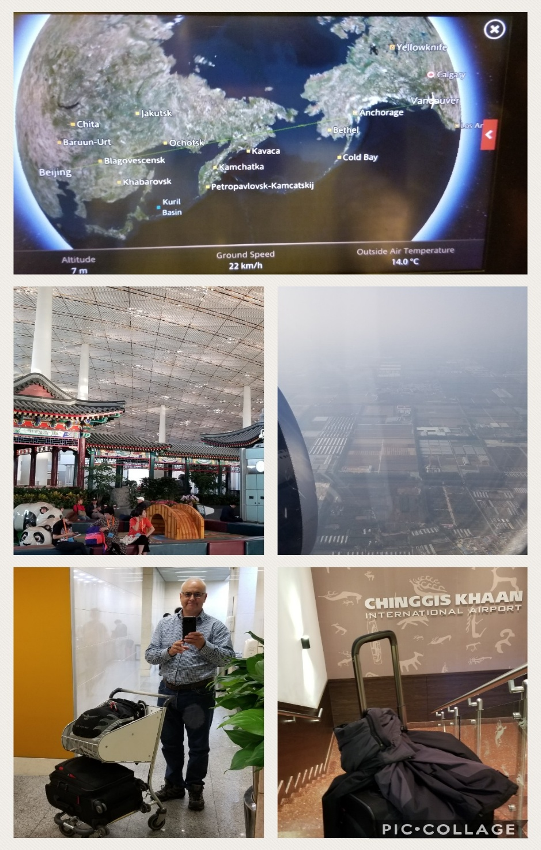

Long overnight flight to Beijing. Spent afternoon & eve in the airport. Had managed to get connecting flight with Miat airlines same evening on to Ulaanbaatar. Arrived 11.30pm Sat. Bro Ari arranged with friend to pick me up at airport. They took me straight to small hotel right by his home where he had arranged real good deal with manager. Wanted me to stay close so we could spend as much time as possible together around the Word & fellowshipping !

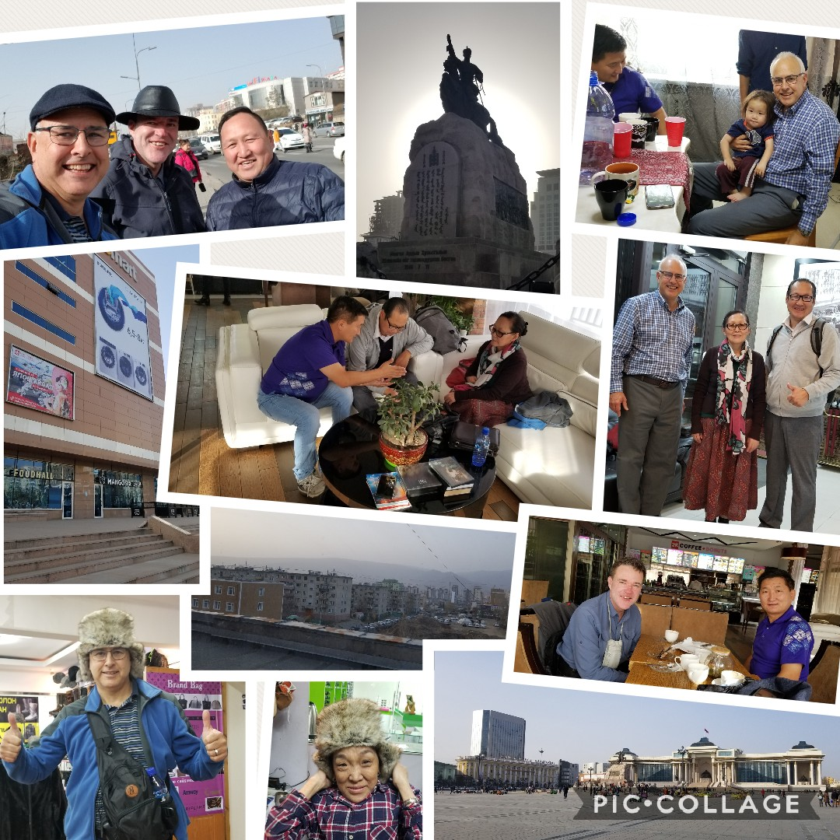

Sat morning met with Bro Ari & friend of his, Paul. Fellowshipped & discussed some issues. Ari had to leave for another appointment Paul and I started walking to find a bank to exchange some funds into Mongolian Tugeruk. While walking down a main road I hear someone yell out a car window as it goes by “Hey Leon". So he pulls over & it was our old friend pastor Ultsi (ex-prisoner) from the church in Zunhara where we had couple of services last year. Can see him in pic above next to guy with hat on. He was real happy to see me and was only in UB for a couple of days. Then driving 10 or 12 hours back to Kuvskol where they have moved to and started a little church. They like it there. I told him the Lord willing you and I may travel up there next time to see him. He drove us to eMart where could exchange currency etc. Don't believe it was a coincidence. Then took long walk past Baptist Church where spoke to pastor Eggi & Sanhuu who informed me they just completed corrections & concordance for the Mongolian King James Bible the previous day & getting it off to print asap. After that to Sukbatar Square & on to say hi to Zola at the guest hse where you Della & I stayed in May. Had snack by Seuol Street & made some calls & texts to try line up some some meetings & apts over next few days. Walked up to Peace Ave & took taxi back aprox 9pm – long day !

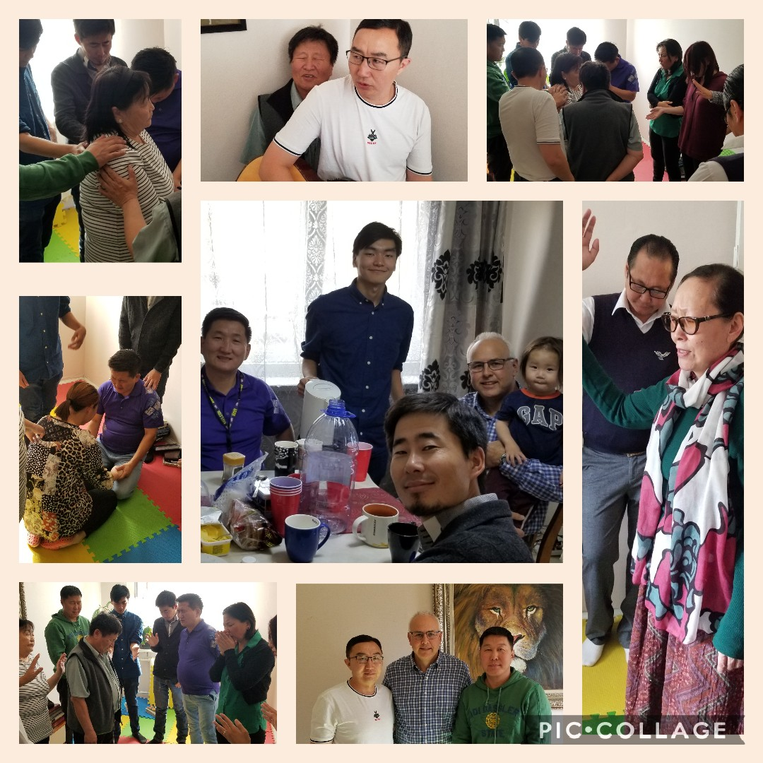Bro Ari had resigned his position as pastor with denominational church organisation about 2 weeks ago & started a home meeting in his apt He is praying & looking to the Lord for His will & guidance for the future. Some of the previous congregation members wanted to join him so they all meet together. I joined them for their Sunday morning service. Different ones shared & some were prayed for.

Afterward fellowshipped together. One bro Munguu played guitar for the worship & translated into english for me some of the things said. He has a language training center for teaching english Bible words. Later met with Bro Ari, Sis Oyunaa & Bro Cornel at hotel. Bro Ari brought all books he was given by someone else including ones from Germany etc & was told the Church Age book was wrong etc This was after we had given him the Church Age book earlier on this year in May. And after you & Sis Della had met up with him in Chicago & baptized him in the name of The Lord Jesus Christ. He said the parts which he read were a great blessing to him. He had been excited with the Word & what God was revealing to him ! But this really set him back, brought confusion, loss of confidence & doubt !

For the next couple of hours seem like intense spiritual warfare. Satan was not happy. By God's grace & help managed to lay out God's pattern from the Word of one prophetic voice to this end time generation as John the Baptist was one voice to his generation ! A vessel that God preserved & wouldn’t even let smoke or drink or be defiled for the great work of bringing a pure Word message to call out a Bride for Christ & vindicated & backed up supernaturally around the world. A prophet reveals the mind of God. I let them know how I cannot even comprehend how anybody can take the words of individuals that have zero vindication, living in adultery, married a couple of times etc etc above the words of a God ordained Scriptually identified vindicated prophet !

After some time Bro Ari pushed aside all the other books put them on the floor & said he has no use for them & to get rid of them ! He kept the books of Bro Branham – Seals, Church Ages etc. Cornel struggled for a while longer but praise God finally by the help & wisdom of the Lord there was victory & it was done – Amen ! The pic is above in the middle with flower pot on table with bro Ari also trying explain more clearly in Mongolian language for them ! Full Sunday 🙂 God is good !!!

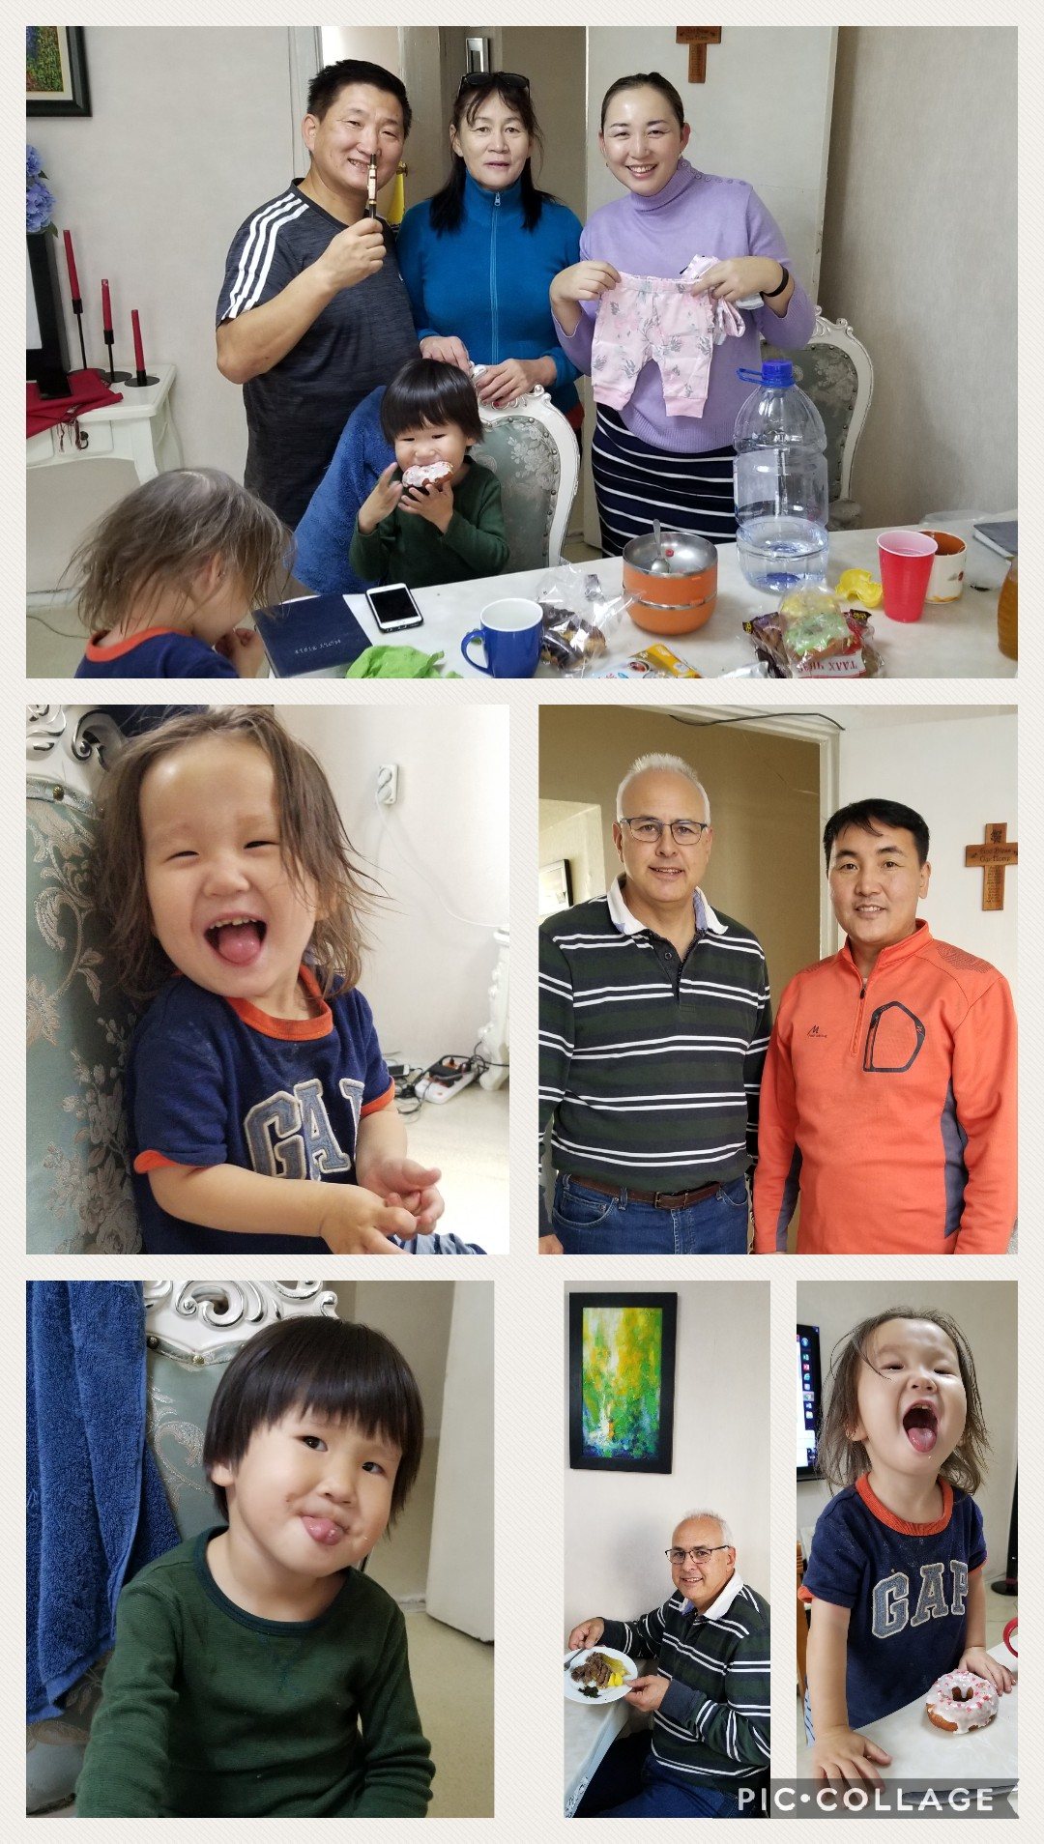

Mon morning went over to Bro Ari for fellowship. Gave coupla gifts from Canada to him his wife & kids. Met a neighbor friend & Christian bro who is a musician, orchestrating & conducting. Said would try put in contact with musicians I know in Canada & US who may be able to help with advice etc They prepared me some horse meat which supposedly helps keep you warmer in the winter - wasn't too bad 😆 !

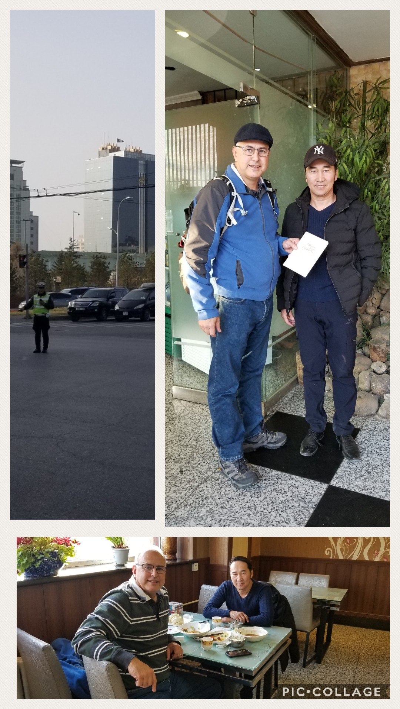

Afterward met with Bro Enk who we met at Papa's café & translated some of the services we had in May. We had given him resume of the ages which we asked him last time to try get translated. He is half way done as was very busy working his tour jobs during the summer ! Going to try finish that translation while here ! Had excellent time around the Word & diff gifts callings & ministeries. Not sure if you saw the email I sent Bro Kobus. I cc'd you. He does not have Church Age book ready for translation but says he can reassign the name of someone else who is ready to translate another message he has ready which is “Christ revealed in his own Word”. He mentioned you had informed him Sis Sheerah is unable to translate at the moment while on extended trip. We could maybe talk about a couple of other messages he could get ready to be used with the translation tool.

Also contacted Sis Nina & her husband in Tunkel & Bro Itgelt in Darkhan who really want to get together so trying to work everything out !

God Bless you !