**Mongolia Missions Trip Oct 2018**

**Summary – Part 3**

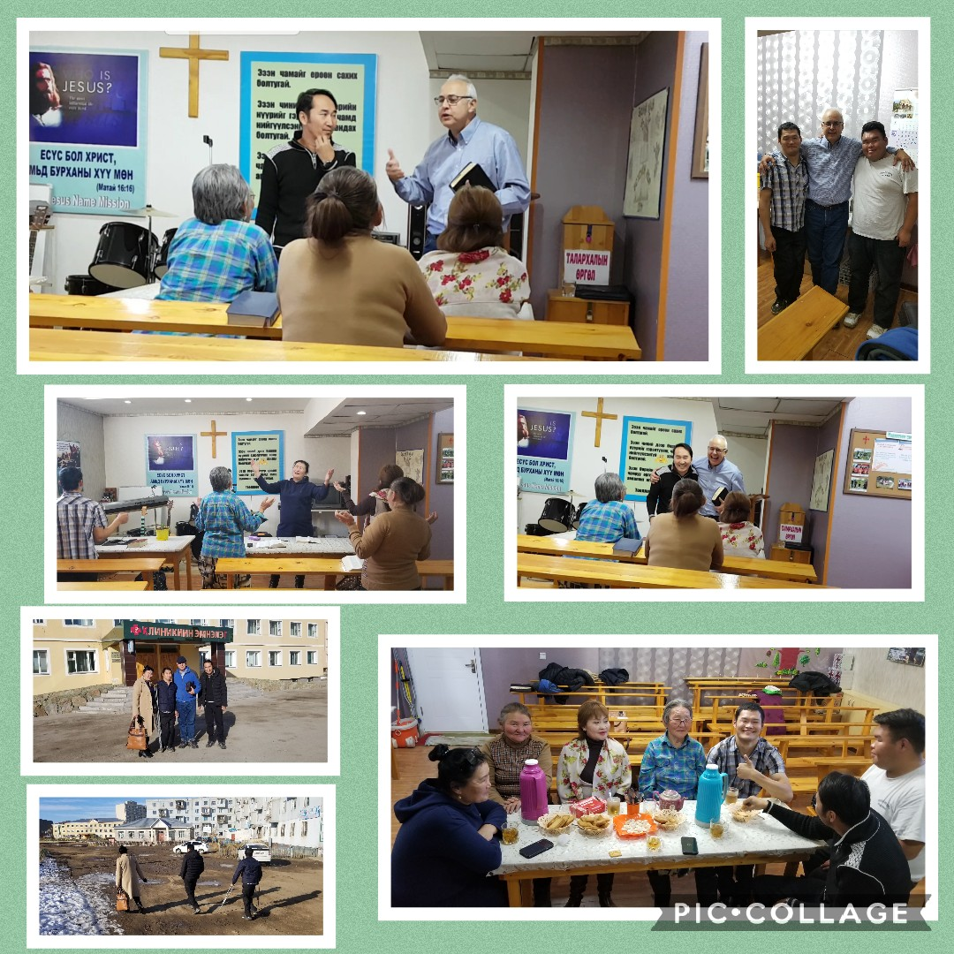

After arriving in Darkhan late & fellowshipping for a while with sis Amara & bro Gomboo (standing in front of building above), we retired for some rest for the evening.

Sunday morning we walked to the building where they rent a basement room to hold Church services in. They had asked me to take the service that morning. Read Scripture ‘ Christ in you the hope of glory ‘ & expounded. Shared also on promised Restoration of Word & Revealing of the Son of Man & Mysteries in this Endtime Mal 4:5,6 Rev 10:1-7 Rev 3:14-22 Luke 17:30 Math 17:11 Acts 3:18-21 Amos 3:7 etc & overview of Church Ages, Seals, open Book, Word Bride etc. Bro Enkee was inspired & shared a few things after too. I told the people I am not a preacher but this is what happens when you have someone who is a preacher translating ! End up with a longer service ☺ Encouraged them to have faith & believe & confess God’s promises for their needs – same Gospel today in the power & demonstration of the Holy Ghost! Also Heb13:8 ‘Jesus Christ the same today’ Mal 3:6 ‘ …Lord, changes not.’ We united in prayer for some needs before having a snack & more fellowship around the Word. People happy & expressed their thanks ! Appreciated having a good translator & seeing the people Blessed.

Bro Enkee & I left & made couple of calls to see if we could reach some new contacts bro Danny, Sis Della & myself had met after we were in the high security prison outside of Darkhan on our last trip. Only managed to reach Shagai (top left pic below) who is involved with the men’s ministry and helping different ones with alcohol addiction etc. Discussed different things about their program & work. Their offices are just down the road from the church where he fellowships with approximately 100 people. So told him hopefully we’ll get to visit the church next time. After went back to spend time & fellowship with Sis Amara and Gomboo shared testimonies etc.

Monday morning met with pastor Baggi (yellow shirt) at coffee shop adjoining his church which a young man & his sis run. We met him on our trip 1 ½ years ago. Had good time fellowship around the Word. He belongs to evangelical association of pastors in that area careful to expose anyone bringing any teachings contrary to the Bible. Told him that is very good as heaven & earth will pass away but His Word will stand forever. Paul said let Gods Word be true & every man’s word a lie. Also Gal 1:8 ‘anyone preach another gospel – accursed !’ & Rom 2:16 – God will judge the world by Jesus Christ (Bible) according to Paul’s Gospel not some religion or denomination. Told him people thru Bible history always seemed to fail to recognize the Scriptures promised in their day ! Also discussed diff Mongolian Bible translations. He was happy to see previous president of Mongolia and his wife arrive in the coffee shop, who we greeted ! Before we parted encouraged Baggi who is fluent in English to read the Church Age book which we had given him on our last trip which he hadn’t read yet !

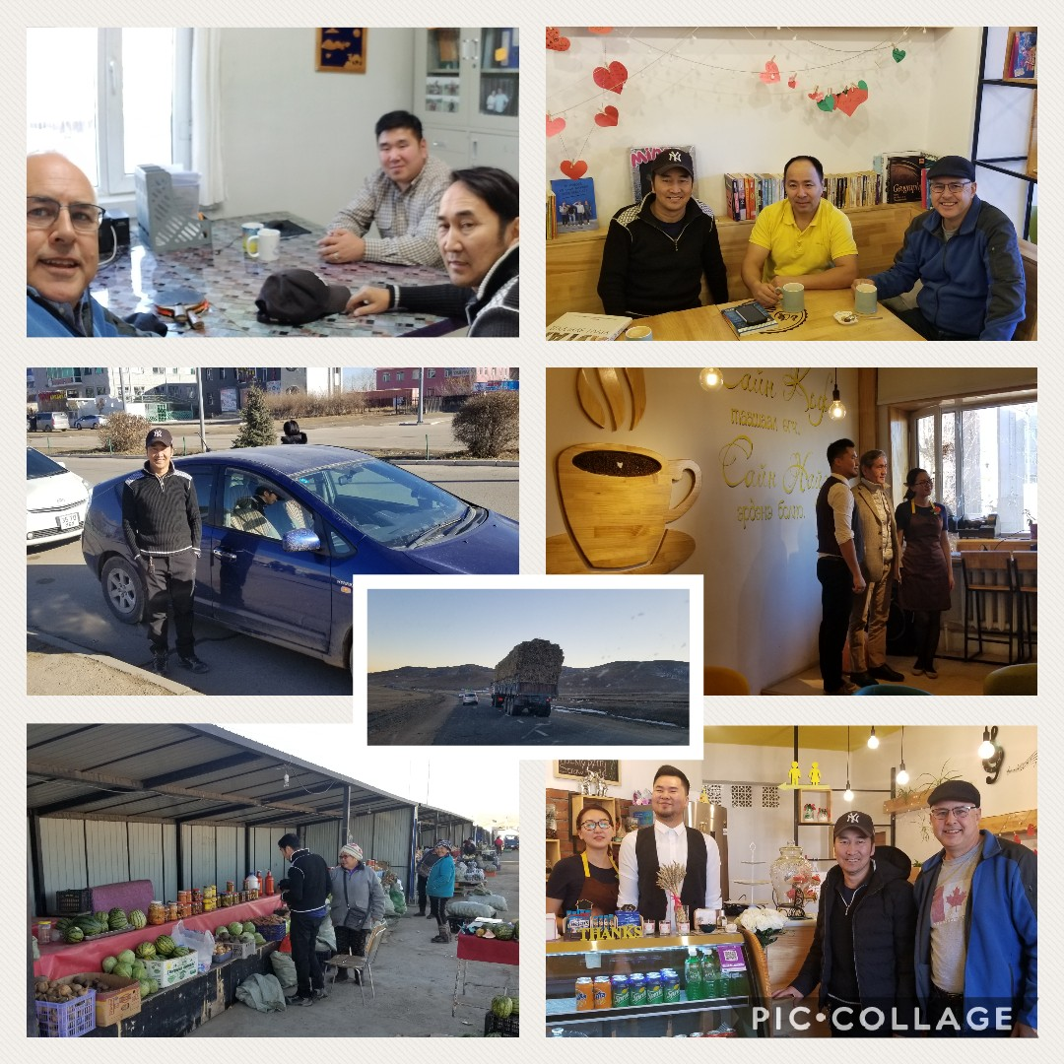

After meeting drove to village of Barunharaa. Unfortunately the pastor David was away for the day. His wife Selenge (pink top) & children were home. I told her that her and her husband were special to us because God had brought us together when we were driving through their village 1 1/2 years ago. I asked at that time if there was a little Christian Church in that village and a local said yes so the next thing we were fellowshipping with around the Word of God, bro Danny & myself sharing many things for about an hour or two. Before we left pastor David told us that he had prayed at 5 o’clock that morning that God would send someone his way that day to encourage him in the Word of God and show him some things from the Word and he just wanted to let us know that. I let him know that it had nothing to do with myself or bro Danny but that was his God that he had prayed to answering his prayer and we just happened to be driving through his village ! We had left them a few message books as well that time. Wanted to get some Russian ones to them as didn’t understand English but did understand some Russian.

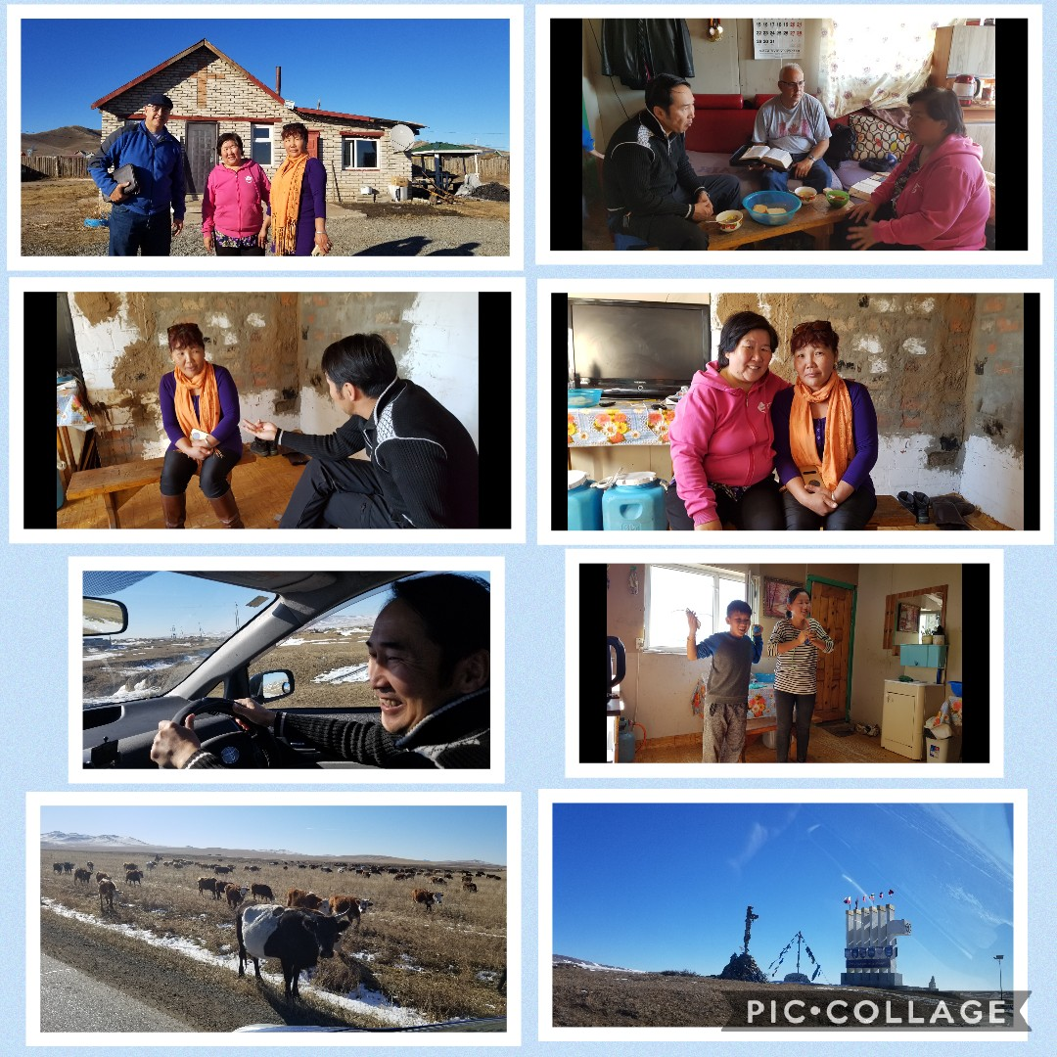

A good friend of sis Selenge who lived about 18 Kms away in in the country was visiting and so walked into their little home adjoining the church while we were talking and fellow shipping. Selenge had asked me to explain water baptism the way we see it so I opened my Bible and we went through Scripture verses just laying out true Christian water baptism in the name of the Lord Jesus Christ ! She was very grateful and thankful and said seemed explained from a different angle and she understands and sees it. She told us the lady who walked in was her good friend but was not a Christian. Bro Enkee took the opportunity in the Mongolian language to witness to her about salvation. After a while we were praying together with her as she surrendered her life to Jesus Christ right there. We encouraged her to continue on and get together with Selenge & other believers and read the Bible and pray and keep the inner man strengthened. She asked if we came back there again if we would come and visit her in her Ger home I believe which is about 18 miles out of Barunharaa in the country and gave her cell #. She said she felt very peaceful and happy after praying. I asked sis Selenge to please tell her husband that we were very sorry we missed him and hopefully next time would work to spend some time together !

Brother Enkee and myself continued on road trip back to Ulaanbataar ! We had a wonderful and special time of fellowship talking about many different subjects and things in the Word of God in the message of the hour ! He expressed thanks & felt God had blessed him with revelation on many diff things! Thank the Lord ! Got back to UB in the evening. Bro Enkee’s wife had to work & just finished so I offered to take them out to a nice restaurant for dinner. Also appreciation for bro Enkee being away from his family to help translating ! Showed his wife the pictures of our road trip & the ones visited and testimonies. Also showed picture of my family and ended up giving them my daughter Chaela's testimony of healing from epilepsy as a baby which they rejoiced about & appreciated ! Was a nice end to a Blessed road trip !

Tue morning Bro Cornel asked if I would come over to his home and also that he was feeling quite sick and not doing very good. Took taxi over to his apartment ! Sis Oyunaa arrived too. He still had questions about the Church Age Book because of things they heard & read trying to discredit it bringing confusion also saying Rev 10:7 not fulfilled etc. Shared many Scriptures & Quotes ,also from the tapes, letting them see & read them directly showing it was contrary to the seeds of discrepancy which they were told & read. Shared Bro Branham’s own words from the message tapes & other info verifying the Authenticity of the Church Age book:- Where he said : “from magnetic tape we’re going to write a commentary on the 7 Church Ages to send into all the world" , “ I must go to Jeffersonville to write this book ….if I express this & it goes on writing, after I’m gone the words will live on.”, ” talking on our Church Ages ( which we have the books now that’s coming out) ….about my writing of the Church Ages.” He had bro Lee Vayle help write & grammarise it. Bro Branham overseen, edited, made changes, ok’d it, said it was correct, was in agreement of final proof, before printing & distributing at the end of 1965 after 4 plus years. Also understand he personally signed many copies given out to ministers at that time. Bro Branham said in the message “ Trying to do God a Service” 65-1127B “ You all seen in my book, it’ll all be drawed out in the ‘Seven Church Ages’ which He told me; which I stand as a witness to God to be judged at the day of Judgement for it. It come from God, not from my own thinking. “ We take for granted sometimes that we being English speaking can search these things out in the message, but most of these people in Mongolia understand very little, if any English. Let them know I feel satan despises this book as it was completed in 1965 after the preaching of the Church Ages & the Seals & includes those things that were Revealed as well as other doctrines & truths, also exposing the enemy in his tricks & deception. Also that true & faithful ministry will be in harmony & agreement with the Word & Message & not lift themselves up above the God ordained Prophet/Messenger or any other 5 fold ministry in Eph 4 as having some special ministry above others. They lift up Jesus Christ & His Word helping to get a Bride ready for a Rapture ! Felt the Lord helped break them free from confusion & fortify them against any false teachings etc in the future. Hearing bro Cornel express his thanks & that he understood & was done with was a great blessing after hours of labouring ! Trusting they can in turn help others. Laid hands & prayed for healing in his body too.

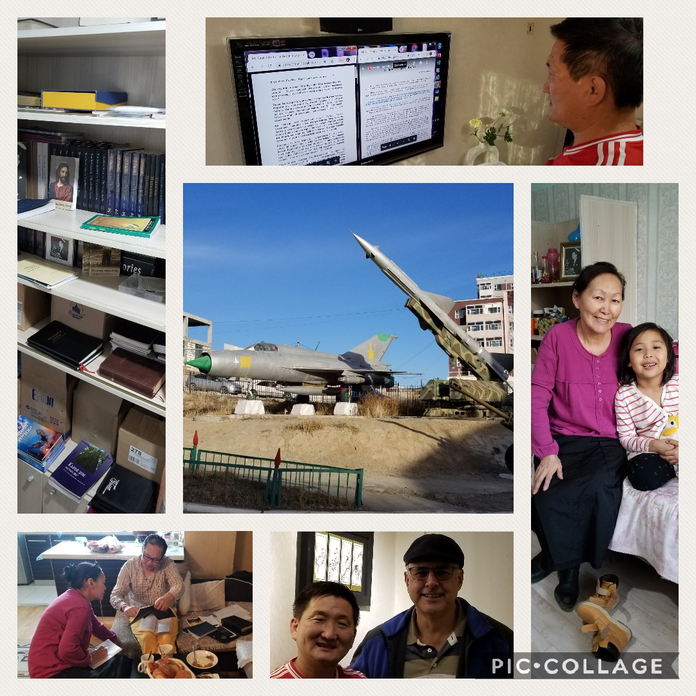

After that took a taxi to brother Ari’s apartment and spent the evening with him & his wife & family. It was a special time with bro Ari just sharing testimonies and also disappointments, trials & difficulties & things that he had been through over the years with different leaders, preachers, church organizations, boards that he had been involved with as a pastor & minister. He was just taking things slowly, prayerfully, cautiously, seeking God’s presence in his life & will for the future after withdrawing from the denominational church where he was pastor, in a step of faith a couple of weeks before. They offered him a very healthy salary to stay on, after previously cutting it in half, but he turned it down saying he would then feel like he was a pastor of money & not a right heart for God’s sheep & will in his life.

His wife sis Sarah had asked me to share from the Bible a few days before about water baptism but we were interrupted & not able to finish. So we went thru Scriptures on Godhead & baptism which they followed in their Mongolian Bible. Started in Gen1:27 Adam created in the image of the one God, thru to the last Adam, Jesus Christ – express image of the invisible God & how their wives were taken from them (Eve/ Bride) etc After seeing it she wondered what she should do as she was a Christian & already baptized years ago. I told her the true Church is a continuation of that original Book of Acts Church & would do it the same way (Acts 2:38) in the Name & not just Titles ! Same as in Acts 19 where Paul met disciples & they were baptised again the right way in the name of the Lord Jesus Christ in obedience to the Word, receiving the Holy Ghost. And the Gentiles in Act 10:44-48 who had already received the Holy Ghost while Peter preached to them, were still baptised in water in the Name. Encouraged her to pray & walk in obedience to what God reveals, otherwise he is not obligated to reveal another thing to us from His Word.

After that she said she had a question about Elijah supposedly having come. So spent another hour or so expounding to her & bro Ari God’s pattern through history in the Scriptures & the things promised for our day ! Let them know that the True Church is built on the rock of the Revelation of Jesus Christ as Jesus said to Peter in Math16:17,18. Encouraged them to continue to pray and let God give them Revelation of the truth of what he’s done in these last days in Restoring the Word of God and Revealing all the mysteries that were sealed as Daniel & Revelation said until the end time ! That it was the Son of Man Jesus Christ revealing himself through a son of man (prophet) which was the ministry of bro Branham according to Luke 17:30, Rev 10:1-7, 1Thes 4:16, Mal 4 etc Also read and showed the sad condition of the Laodicean Church age with Christ (the Word) outside of the churches. It was a blessed & special evening together & felt a real sweet presence of the Lord thru the evening & couldn’t help but think of the many prayers prayed of the saints all over for the Bride & God’s people & work of the Lord in Mongolia. We also pulled up the message “Eagle stirreth her nest” on his computer opening it in split screen with Monglian on one side & English on the other. Talked about translations & corrections with Bro Ari & his wife sis Sarah, who is a linguist & open to helping. Bro Ari expressed their thanks & appreciation coming over on this trip & that he felt it was the right timing & very needful. We’re thankful to the Lord ! I let them know there’s many people that are praying for them & the family of God in Mongolia !!!

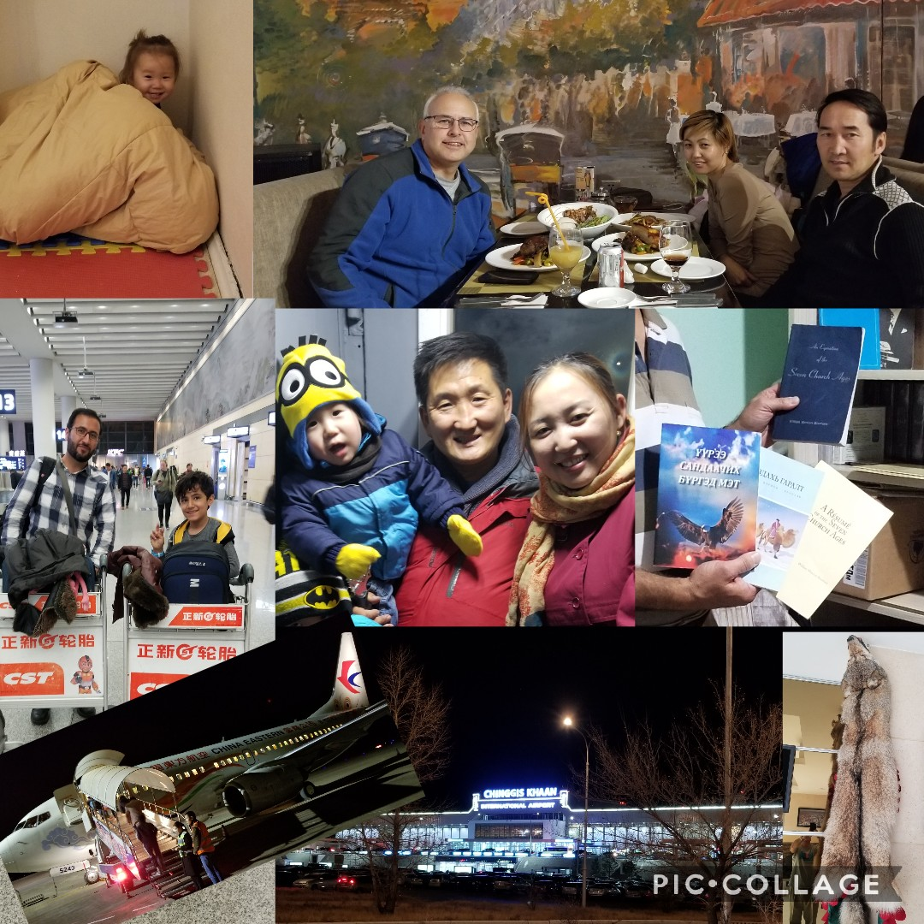

Wed made calls to take care of final things as last day before leaving for China in the morning. Took taxi to sis Oyunaa’s apartment. Time of fellowship & encouragement with her & granddaughter! Checked what we have for stock as far message books & materials etc a lot of what we brought over on our last trip & bro Danny on previous trips in an extra suitcase over the years etc. Also what is left over from the couple of messages we had printed in Mongolian on our previous trip. Let her know we appreciate her & how her Godly life, way she dresses, not cutting her hair etc have been a great blessing, example & witness to others there in Mongolia. I believe mostly brought about by feeding on the message in Russian over the years together with her husband Bro Turu before he went to be with the Lord in the last year. They were at Bible school in Russia years ago & understand the language! Quite a few of the older Mongolians can understand Russian which is a great blessing for them !

Afternoon went over to bro Ari’s apt to say farewells etc. Left couple of packages with him for others including a Russian cd’s & message books package for bro David, pastor in Barunharaa & his wife Selenge! Also left him with the ‘Token' , ‘ Christ is the mystery of God revealed' & others to read & let him know we will be praying for him during this time of transition & seeking God’s guidance & will in his life ! Please remember him in prayer !

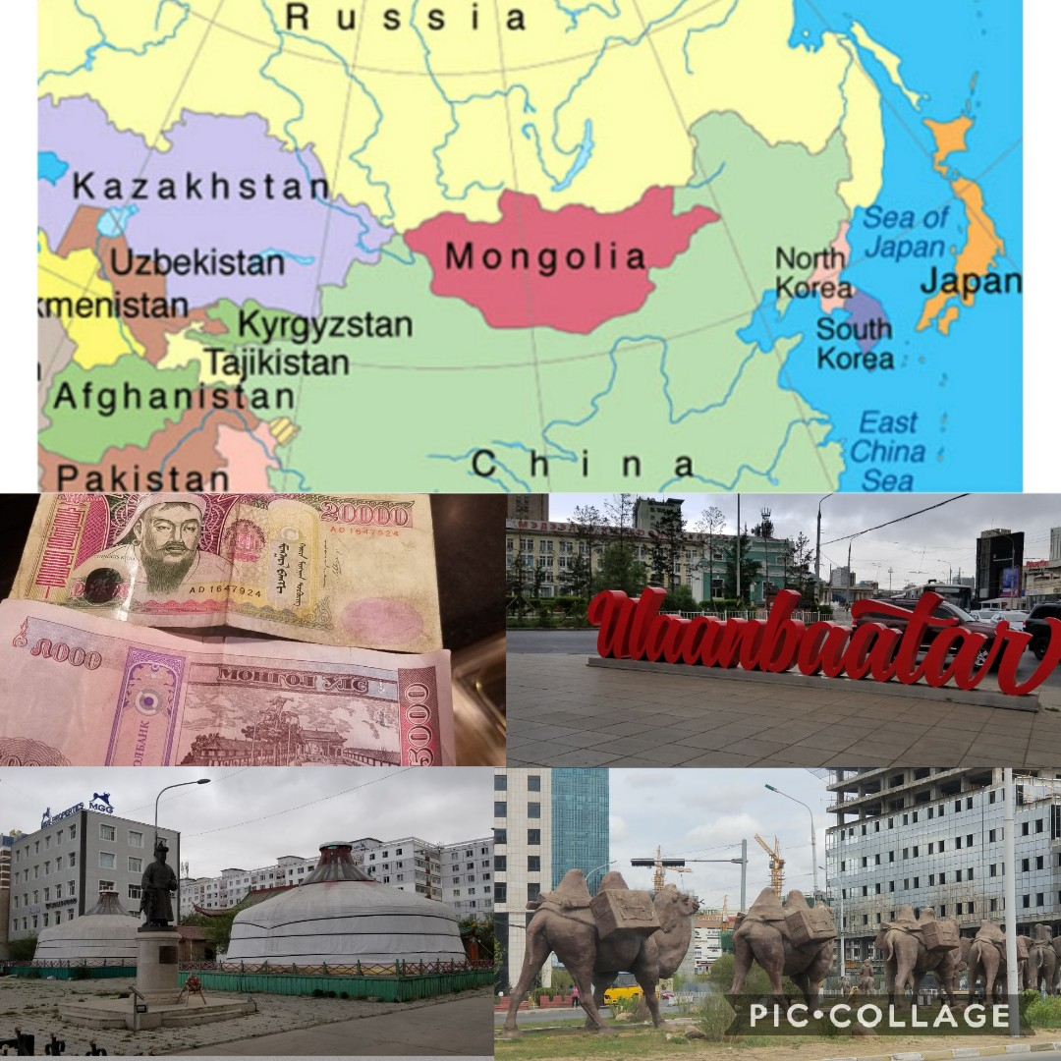

Spent the last evening with bro Enkee, his wife & children in their apt. Gave him some single books in English too including “Anointed ones at the end time”, “Token” etc Fellowshipped & shared on worship In Spirit & Truth, Pentecostals, Charasmatics & Fundamentals, Armenianism & Calvanism, Dynamics & Mechanics & a balance, middle of the road etc Also discussed Resume of the Ages which he has almost finished translating into Mongolian. Talked about proofing etc once completed. Says he should have time in the winter to do more ! Let him know appreciated all his help & translating over our time together, openness to the Word & genuine feeling for his people. Nice to hear him say he appreciated my heart, love & burden for God’s people in Mongolia ! Please remember him & family, others that have been baptized, the translation work, & for God to continue working in hearts & lives, & to raise up men in Mongolia to carry the truth of the Gospel & Message to their own people, as they understand their culture etc! Feel to get as much done as we can while the door is open, especially with Mongolia situated between China & Russia which seem to be really tightening up !

Bro Enkee dropped me at the Chinggis Khaan airport next morning early to catch flight to China for aprox 3 days, spend a little time with a special bro before heading back to Canada. Ended up missing a flight in Beijing & then sitting next to a Iranian Muslim & his son (pic above China Eastern Airoplane above) on the next flight & having a tremendous witness for aprox an hour or two. They live in China. Very knowledgeable of the Koran. Shared my testimony & read many scriptures together – seemed hungry to hear truth ! Showed him Jesus was more than a prophet – Was God in flesh Isiah 9:6 & Salvation plan, seeds etc. Exchanged info. Told him it was worth missing my flight to be able to talk with him about the things of God even though only arrived at destination around 3am. ‘All things work together for good ….’ Felt the Lord watched over the trip, trusting the seed of His Word fell in good ground, that He would give the increase, bring forth fruits & achieve His purpose ! When we see the open doors, prepared hearts & lives ready to receive the Revealed Truth in our day, can’t help but think of when the Lord in the book of Acts encouraged Paul by vision to continue on in that city as He had “much people in this city“ & we know “as many as were ordained to eternal life believed.” Also Bro Branham talks of going about throwing the net, spreading the Gospel, & while busy if God wants to give a Macedonean call, like He did to Paul, as hearts were ready to receive there, he would drop his plans & follow that call. Feel humbled & privileged for the opportunity God has allowed to be a small part of what He is doing among His people in this country. Appreciate Bro Danny & his missionary heart, & been a Blessing working in the field together as fellow labourers in this ripe harvest time. The Lord Jesus has a Bride in Mongolia ! Pray for them during this time of stirring & calling ! Trust report is a blessing & sorry if too much detail

God Bless You, Shalom !

Your Bro in Christ

Leon John8:32 “And you shall know the Truth & the Truth shall make you free.”

[bibletruthmongolia@gmail.com](mailto:bibletruthmongolia@gmail.com)